*SIMPLE 2D CAD APPLICATION* Product Design Specification

Team: Insignia Version *<1.0>*

*02/11/2001*

Team Members:

1. MANAN SETHI
2. TASHU CHUGH
3. TANYA GOYAL
4. Abhijeet Singh HADA
5. SHIVAM TYAGI

**TABLE OF CONTENTS**

1. **INTRODUCTION**
   1. PURPOSE OF THE PRODUCT DESIGN SPECIFICATION DOCUMENT
   2. PROBLEM DEFINITION AND SOLUTION
2. **FUNCTIONAL SPECIFICATION**
   1. FEATURES
   2. PERFORMANCE
   3. HARDWARE REQUIREMENTS
   4. DETAILS OF SCENARIOS
3. **EXTERNAL USER INTERFACE**
   1. USE-CASES
   2. APPLICATION PROGRAM INTERFACES
   3. USER INTERFACE DESIGN
4. **TECHNICAL SPECIFICATION**
   1. SYSTEM ARCHITECTURE
5. **REFERENCES**
6. **INTRODUCTION**
   1. PURPOSE OF THE PRODUCT DESIGN SPECIFICATION DOCUMENT

Our Product Design Specification document documents and tracks the necessary information required to effectively define architecture and system design in order to give the development team guidance on architecture of the system to be developed. The Product Design Specification document is created during the Planning Phase of the project. Its intended audience is the project manager, project team, and development team. Some portions of this document such as the user interface (UI) may on occasion be shared with the client/user, and other stakeholder whose input/approval into the UI is needed.

* 1. PROBLEM DEFINITION AND SOLUTION

2D CAD can be used across a wide range of industries such as automotive, aerospace, fashion and industrial design. Helps increase productivity of a designer. It is used to design Curves and figures in two-dimensional and is used for accurate creation of photo simulations.

CAD 2D is a free intuitive painting and drawing application designed for people of all skill levels, who love to draw

This is a very easy program to use to Create or Modify an existing picture useful for tablets or mobile phones and a wonderful drawing program for all ages to free your imagination and inner artist

1. **FUNCTIONAL SPECIFICATION**
   1. FEATURES
2. Assist with the design’s creation, modification, analysis, or optimization of a design.
3. Handling objects such as shapes (for now, circles, quadrilaterals and lines) and layout for different applications.
4. Designs can be copied and pasted easily from
5. Drafting views such as planes, sections, and elevations, designers can visualize completed design and make any amendments as needed.
6. Software is much faster than manual drawing methods, it also allows designers to explore different design options more efficiently.
7. Being able to insert commonly use components into a drawing greatly speeds up the drawing process while also removing the potential for errors.
   1. SYSTEM REQUIREMENTS:

**Operating System:** - Window XP of higher with latest updates installed

**Processor**: - 500Mhz or more

**Ram**: - 128 MB or more

**Graphic** **Card**: - At least 64 Mb or more

* 1. PERFORMANCE
  2. DETAILS OF SCENARIOS

Line:

There are numerous ways for drawing a line. There can be as follows:

1. Firstly, we can draw the line free handily just by selecting the line tool and draw the line wherever you want. Talking about another way we can define two points and there will be line created.

2. Mistakes that can occur while we are trying to draw line is that you drag your mouse pointer out of the screen the line will not be created and in case of the two points if the user enter wrong values.

3. While you drag the cursor out of the screen it will pop up the message that you have taken out the cursor out of screen and if you reach the end of the screen it will say that you have “Reach out of bound”.

4. You can retry the changes just by clicking on the undo/redo button.

**CIRCLE**

There are various user interactions possible for a circle.

First, we will be talking about how can we draw a circle in the application. So, there are 4 possible ways for the same. The first one being when we drag from one place and drag it down to the point where we want out circle to add. Basically, what we are doing is we are dragging the cursor and making a rectangle in which a circle will be filled. Next possible way will be we can specify a radius and a circle will appear with the same radius. Continuing further we can also draw circle by dragging the circle from the center to the corner of radius.

Next, talking about the mistakes that one can encounter the dragging can sometimes be quite large that the circle isn’t drawn. Also, there is a possibility that the radius entered by the user is quite large and the circle isn’t drawn.

The Expected messages for the error can be “There is no such circle possible”, or “There is an error! Please look carefully”.

1. **EXTERNAL USER INTERFACE**
   1. USER INTERFACE DESIGN

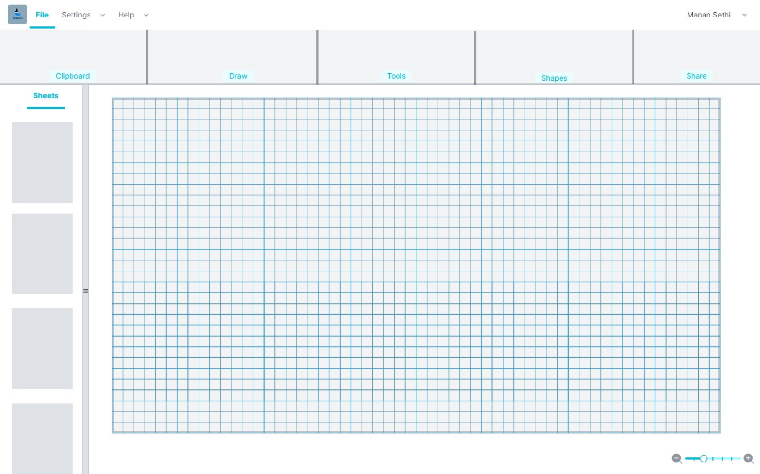

1. **TECHNICAL SPECIFICATION**

**Technical specification**

* **Hardware detail**

Any dual core and higher processor

RAM greater than 64 MB

* **Operating System**

Window 7 and above

* **Performance**

Optimal performance as the app doesn’t requires much RAM,

* **Programming language and technologies**

IDE used -> Visual studio

Programming language -> C#

* **Version Control**

GIT version control